**"An Object-Oriented Dealership System"  
PART 2**

**A Java Mini-Project**

**Project Description**

In this project, you will add Sales and Leasing to your dealership. This means you will need to add a more option to your menu - SELL/LEASE A VEHICLE.

When the user records a sale or a lease, you will need to:

* collect basic sales information from the user
* add the vehicle information to the contract
* ask if it is a sale or lease (Note: you can't lease a vehicle over 3 years old)
* calculate pricing

The difference between a sale and a lease is based on how pricing is determined.

**Project Details**

To get this part working, you will need to add the following classes:

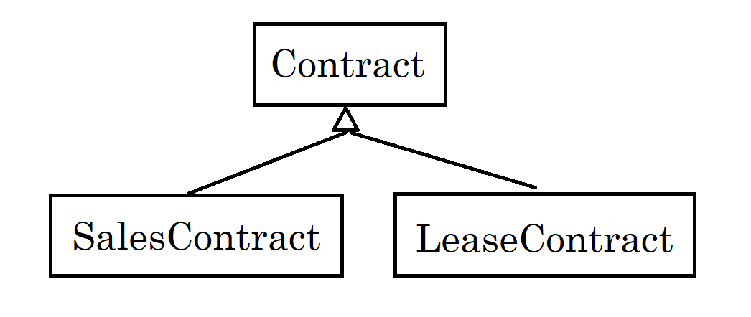

A Contract will hold information ***common to all contacts***. It should be an **abstract class** as you can't create a generic contract.

* Date (as string) of contract
* Customer name
* Customer email
* Vehicle sold
* Total price
* Monthly payment

Methods will include a constructor and getters and setters for all fields except total price and monthly payment. You should define abstract methods for getTotalPrice() and getMonthlyPayment() that will return computed values based on contract type.

A SalesContract will include the following additional information:

* Sales Tax Amount (5%)
* Recording Fee ($100)
* Processing fee ($295 for vehicles under $10,000 and $495 for all others
* Whether they want to finance (yes/no)
* Monthly payment (if financed) based on:
  + All loans are at 4.25% for 48 months if the price is $10,000 or more
  + Otherwise they are at 5.25% for 24 month

Methods will include a constructor and getters and setters for all fields except total price and monthly payment. You should provide overrides for getTotalPrice() and getMonthlyPayment() that will return computed values based on the rules above. It is possible that getMonthlyPayment() would return 0 if they chose the NO loan option.

A LeaseContract will include the following additional information:

* Expected Ending Value (50% of the original price)
* Lease Fee (7% of the original price)
* Monthly payment based on
  + All leases are financed at 4.0% for 36 months

Methods will include a constructor and getters and setters for all fields except total price and monthly payment. You should provide overrides for getTotalPrice() and getMonthlyPayment() that will return computed values based on the rules above.

**Persistence Issues**

When a user selects the sale or lease option, they will have to provide the VIN of the vehicle they are interested in. Once you complete the data collection for the sale or lease, you will need to APPEND it to a contacts file. If you support multiple dealerships, all contacts still go in the same file.

Example: (Word wrap is only in this document)

SALE|20210928|Dana Wyatt|dana@texas.com|10112|1993|Ford|Explorer|SUV|Red|525123|

995.00|49.75|100.00|295.00|1439.75|NO|0.00

LEASE|20210928|Zachary Westly|zach@texas.com|37846|2021|Chevrolet|Silverado|truck|Black|

2750|31995.00|15997.50|2239.65|18337.15|541.39

This means you will need to create a DIFFERENT data manager class. Name it ContractFileManager and add a method to save the contract by APPENDING it to your contracts file.

**Programming Process**

We suggest you spend the first few minutes porting this project over to Eclipse and adopting Java packages. There are many ways to go about this, but if you are unsure, we suggest:

1. Launch Eclipse and creating a new workspace (dealership-workspace)
2. Within it, create a new Java project (adv-dealership-project)
3. Create a package for the source code (com.hca.dealership)
4. Copy your .java files from your VSC project to your new src\com\hca\dealership folder
5. Refresh your Eclipse project (right-click and choose refresh) so it will pickup your new files
6. Modify each class to have a package statement as the first line
7. Configure the project's command line arguments IF YOU NEED TO in order to pass in dealership file names or otherwise configure where your data files will be
8. Build and test your program to make sure it works
9. In Bash, use git init to create a new Git repo. Commit your changes. Then create a new GitHub repo and push this new project to it.

Now you are ready to begin!

**Phase 1:**

Phase 1 should be the construction of your new data model classes: Contract, SalesContract, and LeaseContract.

**Phase 2**

Phase 2 should be the construction of your ContractDataManager. The saveCotract() method will accept a Contract parameter, but you will need to use instanceof to check the type of contract because the format of what you write to the file changes depending on the contract type.

**Phase 3**

Phase 3 involves the updating of the UserInterface. Add a new command option to gather the input from the user, then instantiate the correct type of contract and send it to ContractDataManager to be saved. Don't forget to remove the vehicle from inventory afterwards!!

At this point you can test and debug!

**Bonus Ideas**

If you finish early, there are two extensions you can add to this project:

1. Add an Admin command to your menu and require the user enter a password to move forward. Instantiate an AdminUserInterface object and call its display. Provide features to examine contracts. For example LIST ALL CONTRACTS or LIST LAST 10 CONTRACTS.

This option will require you to create a new class to manage the user interface (not because it has to happen, but because it’s a fun idea). It will also mean your ContractDataManager will have to be able to read in and return and ArrayList<Contract> objects.

1. Add the ability for a buyer to select from a set of AddOn objects when they *buy* a vehicle. You can hard code the AddOn data, but I envision it containing at least options like the following:

Nitrogen tires Window tinting

All-season floor mats Splash guards

Cargo tray Wheel locks

Price them however you want. But remember, this option complicates the coding of the ContactFileManager -- both writing a reading. A suggestion would be to add it to the end of the contract data.